Tiffany Allen

Josh Chang

Mounish Savier

HW 5 Findings Report

Performance Testing: Baseline Numbers:

Live link (from the log in page): <https://marveldex-c8644.firebaseapp.com/login.html>?

Provided Link: <https://marveldex-c8644.firebaseapp.com/>

* This link provides a variety of links to different aspects of the course including our open hosting documentation, the team page, web application, bootstrap implementation of our web app, testing pages, and our example Users CRUD page. To access our completed application, please click on the web app button or click on the live link provided above.

Application Introduction

We wanted to create an application that gives avid Marvel fans the ability to create discussion thread posts about their favorite characters, as well see all the characters and movies in the marvel universe. Our initial demo application allows the user to see a subset of the Marvel movies, a subset of the Marvel characters, as well as create posts about specific characters and movies.

Application Walk Through:

Given the provided link, the user is taken to this base page featured in figure 1. The link to our final web application is circled in red. Once, the user clicks on this link, they are taken to the login page for the application (figure 2). There is a variety of options for the user from here. If they are an already registered user, they are given the opportunity to log in (the first section). If they have a google account, they can sign in with their gmail account. Lastly, they are able to sign up to be a user if they are unregistered. We keep track of all of the users, so if an unregistered user tries to log in, our application will alert the user that they have not registered and they are given the opportunity to sign up for the application (figure 3). Additionally, it will alert other error messages (invalid email address, invalid password, etc)

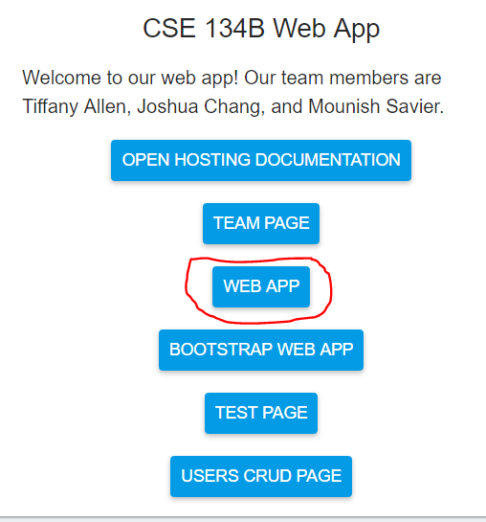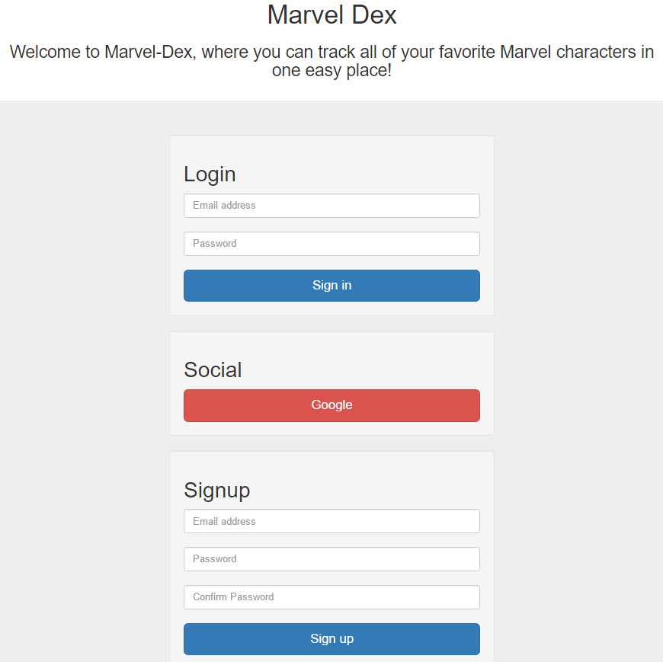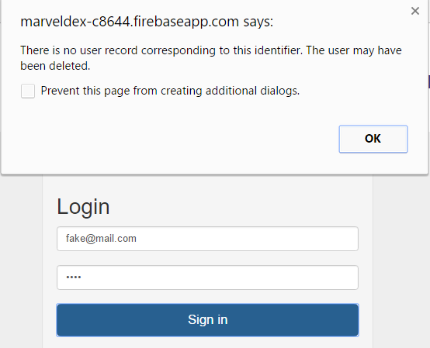

Figure 1: base page. Figure 2: Login page Figure 3: log in error

Once the user is registered and logged in, the user is taken to the marvel home page (Figure 4/5). This is the base page for the application. The “Marvel-Dex” at the top of the page is constant throughout the web application and will link the user back to this home page once the user clicks on it. This home page is the “home base” of our application where the user can view the list of all of the movies in the Marvel-Dex as well as the list of all of the characters in the Marvel-Dex (In this demo application, we included a small subset of all of the characters and all of the movies). There is also a search bar at the top of the screen where the user can search through the Marvel-Dex for specific characters, movies, and discussion threads. In this demo application, we were unable to implement the search bar within the given time frame but we included the search bar to show what we would ideally implement. If the user tries to search right now, they are just navigated back to the home page. There are a variety of navigations from this page, we will go through each one individually.

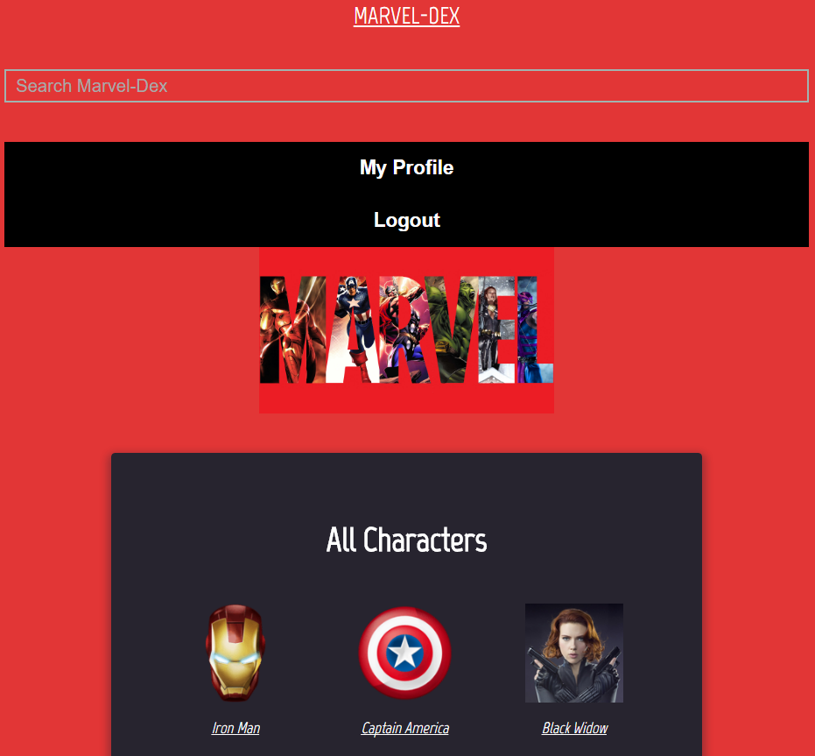 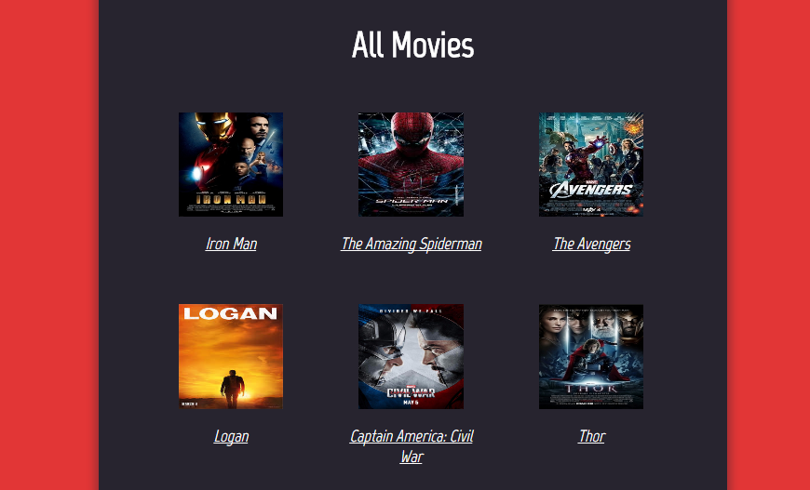

Figure 4: Top of the home page Figure 5: Bottom of the home page

From the Home Page, if you click on the “My Profile” Button, the user is taken to their user profile page (figure 6).

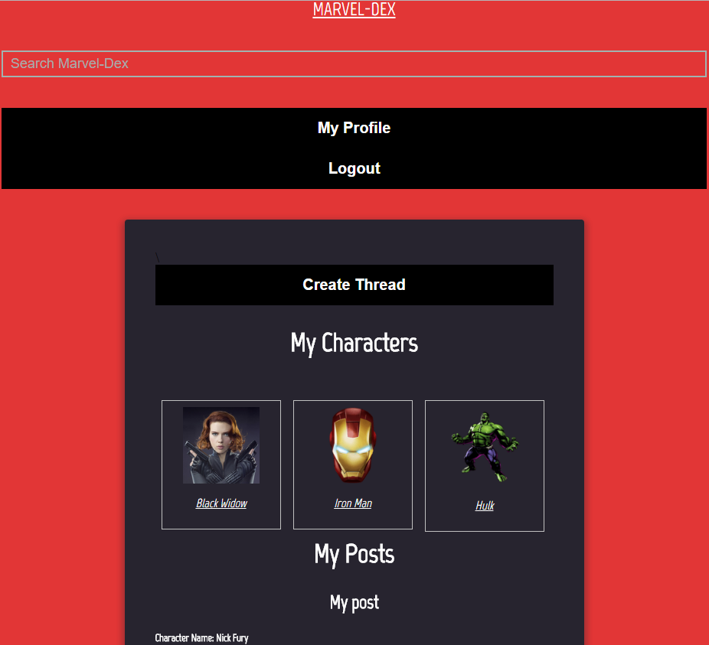

Figure 6: User profile page

Documentation to both the app and the code. With screen captures, demo link and anything that will make the app easy to understand.

Architecture of the code

Concerns

Limitations

Caveats

TODOS